Task 1: SQL CRUD Operations

* 1. For the command input, please see the file: “SQL_CRUD_Operation.sql”
  2. Output:

--Create User by Email

INSERT INTO User (uid, phone_number, avatar, nickname, last_login_time)

VALUES (10/*DEFAULT*/, '15811803568', 'default_avatar.jpg', 'New User', NULL);

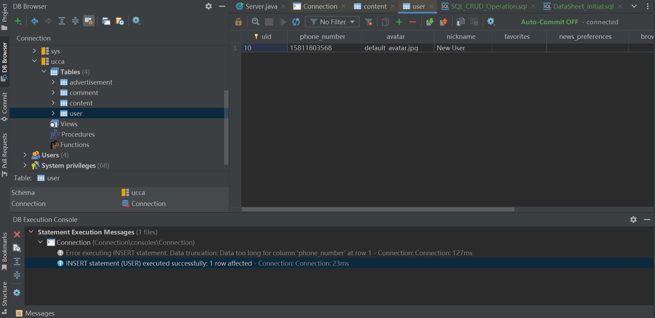

--Edit User Account Information

UPDATE User

SET nickname = 'Updated Nickname', avatar = 'new_avatar.jpg'

WHERE uid = 10;

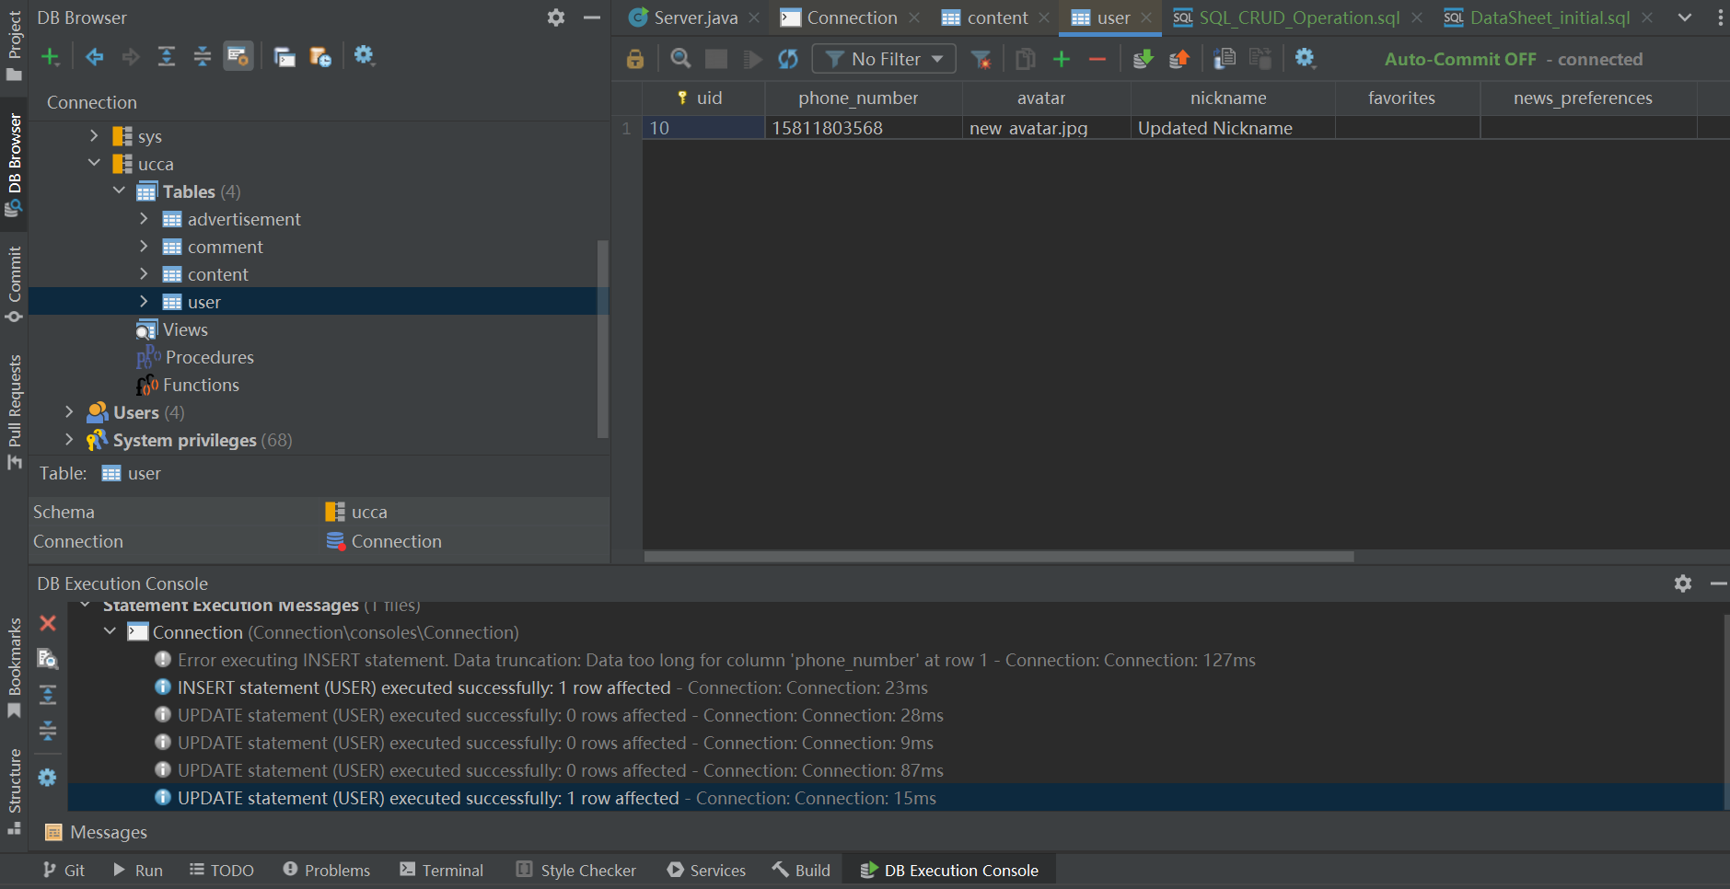

--User Login

-- Assuming phone_number_-based login for simplicity

SELECT * FROM user WHERE phone_number = '15811803568';

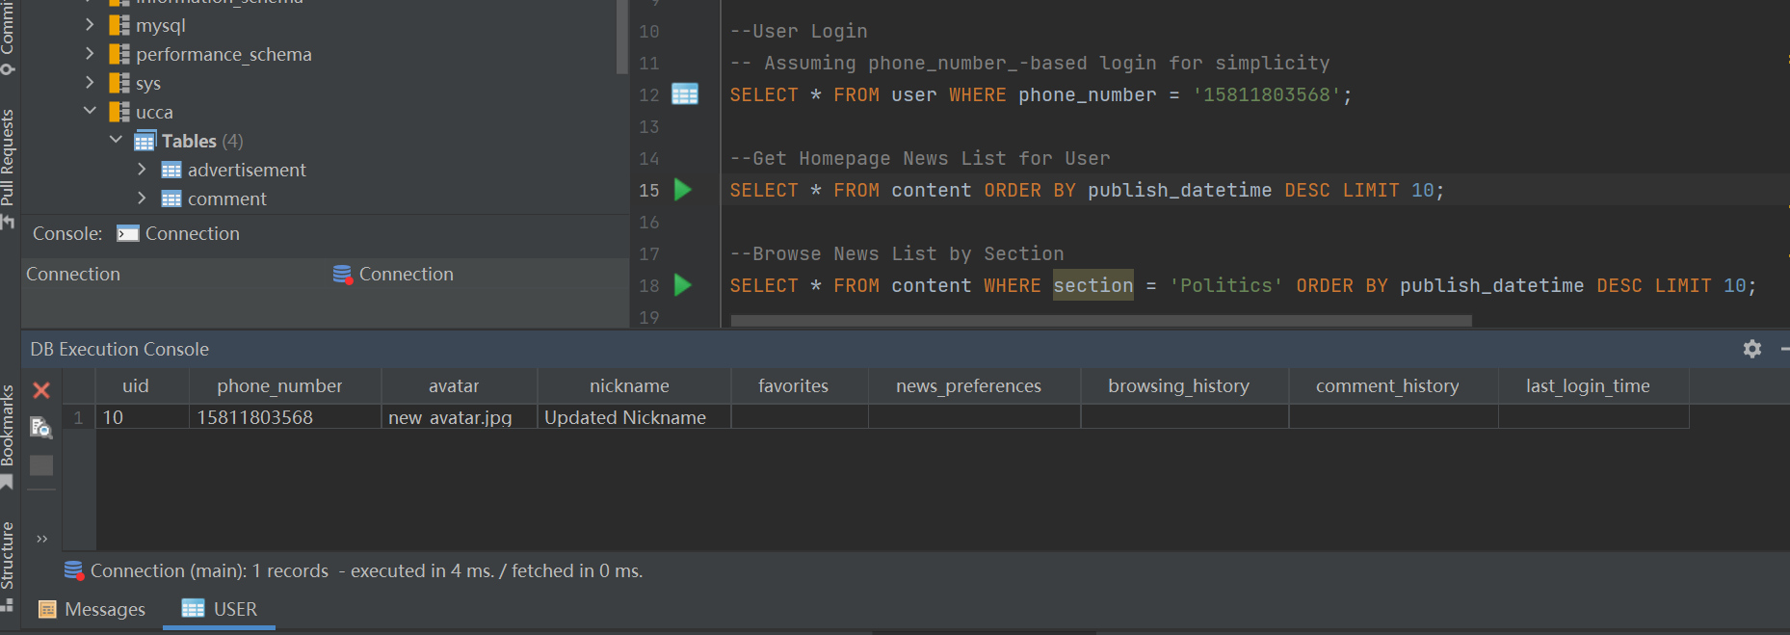

--Get Homepage News List for User

SELECT * FROM content ORDER BY publish_datetime DESC LIMIT 10;

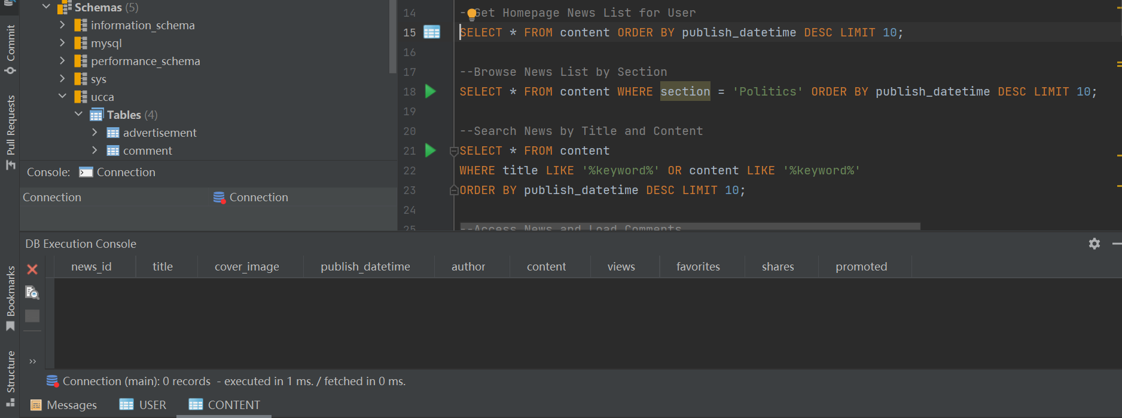

--Search News by Title and Content

SELECT * FROM content

WHERE title LIKE '%keyword%' OR content LIKE '%keyword%'

ORDER BY publish_datetime DESC LIMIT 10;

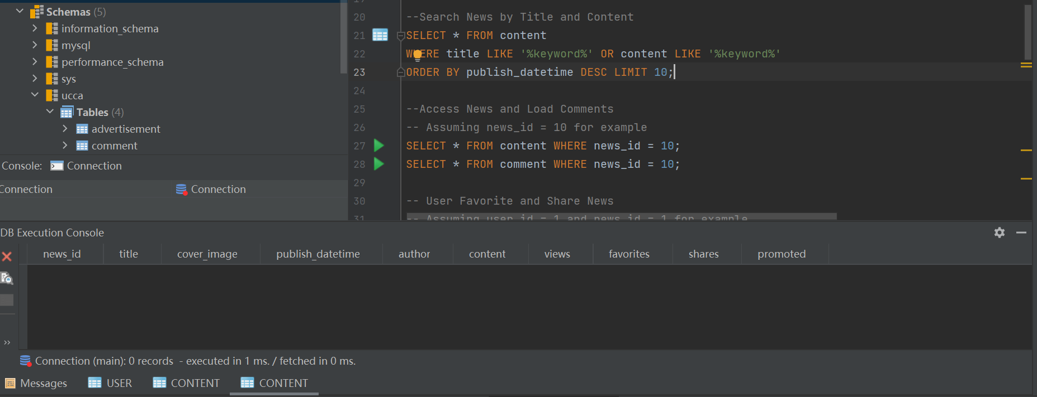

--Access News and Load Comments

-- Assuming news_id = 10 for example

SELECT * FROM Content WHERE news_id = 10;

SELECT * FROM Comment WHERE news_id = 10;

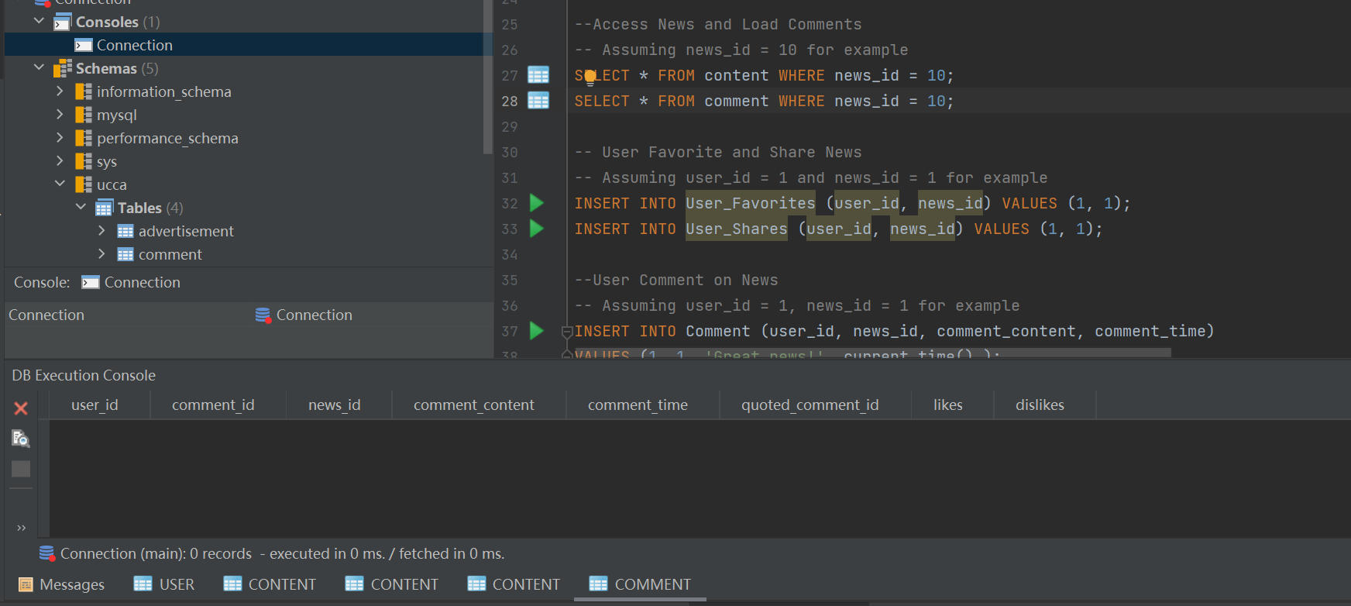

--User Comment on News

-- Assuming user_id = 1, news_id = 1 for example

INSERT INTO Comment (user_id, news_id, comment_content, comment_time)

VALUES (1, 1, 'Great news!', current_time() );

--User Like/Dislike Comment

-- Assuming comment_id = 1 for example

UPDATE Comment SET likes = likes + 1 WHERE comment_id = 1;

-- or

UPDATE Comment SET dislikes = dislikes + 1 WHERE comment_id = 1;

--User Delete Own Comment

-- Assuming user_id = 1 and comment_id = 1 for example

DELETE FROM Comment WHERE user_id = 1 AND comment_id = 1;

-- View User's Comment History

-- Assuming user_id = 1 for example

SELECT * FROM Comment WHERE user_id = 1;

-- View User's Browsing History

-- Assuming user_id = 1 for example

SELECT * FROM Browsing_History WHERE user_id = 1;

-- (Simulated) Publish News

INSERT INTO Content (news_id, title, content, publish_datetime)

VALUES (10, 'New Breaking News', 'Content of breaking news...', current_time() );

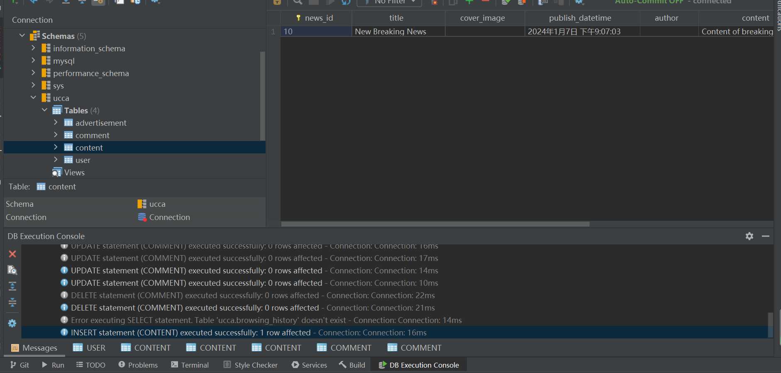

-- Get Ads by Content Type

-- Assuming content_type = 'Politics' for example

SELECT * FROM Advertisement WHERE content_type = 'Politics';

-- Publish Advertisement

INSERT INTO Advertisement (ad_title, ad_content, placement, advertiser_id, expiration_date, region_limit, device_limit, weight)

VALUES ('New Ad Title', 'Ad content goes here...', 'Homepage', 'AdAgency1', '2023-12-31', 'US', 'Desktop', 10);

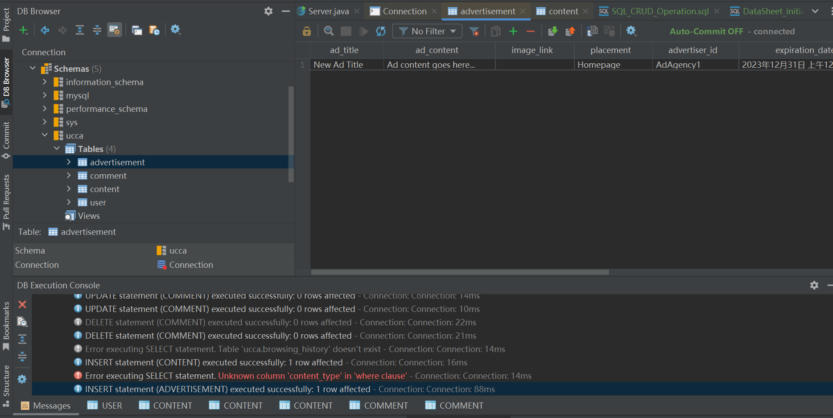

Task 1: SQL CRUD Operations